Angular Acceleration

and

Moment of Inertia

Equipment Needed

Dell Laptop Computer
AC Adapter, Dell Laptop
Mouse
Multi-Clamp, Pasco ME-9507
Clamp, Table Black Humboldt H 21160
Ruler, 12-15in
Mass Hanger, 50g
Mass Set, Gram w/ rack (Assorted)
LabQuest Mini, Vernier LQ-MINI
Photogate & Pulley System, Pasco ME-6838A
Rotational Motion Apparatus, Pasco ME-9341
Calipers, Digital General
Scale, Digital Sartorious BP-6100

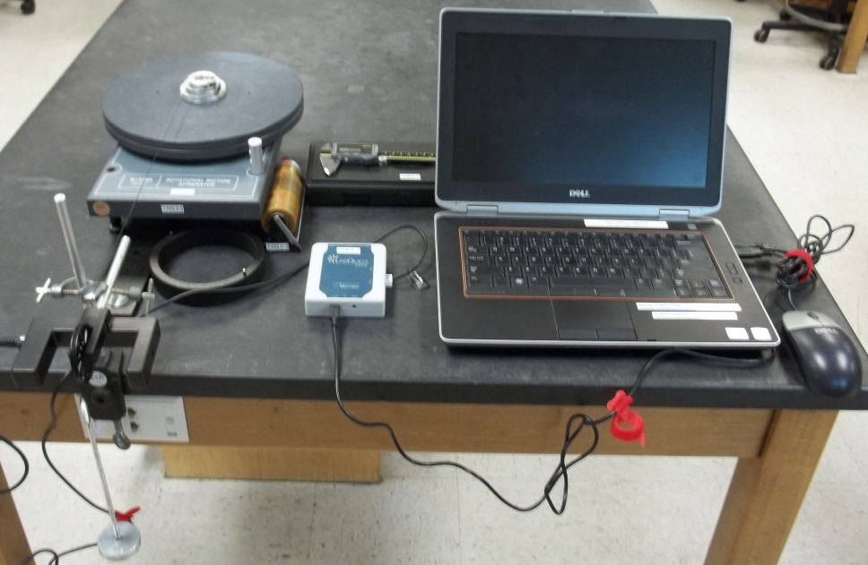
Figure 1 Typical Setup

Theory
In this experiment, we will investigate the concept of moment of Inertia. We will calculate the moment of inertia I of a disk by applying a torque τ to the disk causing it to have an angular acceleration α.
If a force F_{t} is applied tangentially to the step pulley of radius r, found on top of the disk, the disk will experience a torque:
Equation 1
We will solve for the moment of inertia I by using Equation 1 and then compare it to the moment of inertia calculated from the following equation:
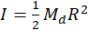
where
R is the radius of the disk
M_{d} is the mass of the disk.
Note: Do not confuse R with r.
We can also place a ring on top of the disk and find its moment of inertia using Equation 1. We will then experimentally find the moment of inertia of both ring and disk together and subtract the moment of inertia of the disk from the total moment of inertia of disk and ring together. Finally, we will compare this value to the following equation:
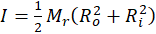
where
R_{o} and R_{i} are the inner and outer radii of the ring respectively
M_{r} is the mass of the ring.

Finding F_{t} , the Tangential Force
Figure 2
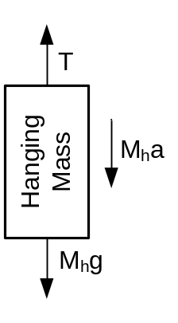
Weight = M_{h}g (M_{h} = hanging mass, g = 9.8 m/s²)

A string will be attached to the small step pulley on top of the disk while the other end of the string will go over a smart pulley and then be attached to a hanging mass, M_{h.}
The tangential force F_{t} on the disk is the tension T of the string. By studying Figure 2,
a is the acceleration of the hanging mass
Rearranging
In this experiment, a is insignificant to g to two significant figures, so that the tension T is approximately equal to Mg.

PROCEDURE
- Set up the apparatus as shown in Figure 1. There is a string attached to the small step pulley on top of the disk. Measure and record the radius r of the step pulley where the string will be wound up. Pass the other end of the string over the smart pulley to a hanging mass, M_{h}. Rotate the disk to wind the string on the pulley in one smooth layer. Plug the smart pulley into the adapter connected to Dig 1.
- Hook up the cables to the smart pulley assembly, the LabQuest Mini, and the computer.
- Turn on the computer and click on the LoggerPro 3.x icon and then go to the smart pulley file. Open→Experiments\Probes & Sensors\Photogates\Pulley.cmbl
- Three Graphs will open along with a data sheet.
- Click ‘Collect’ button at the top of the screen. Release the hanging mass and then click ‘Stop’ before the weight hits the floor or the string completely unwinds.
- On the menu, click Analyze→Autoscale→Autoscale from 0.
- On the Velocity vs. Time graph drag a box a good, smooth section of data.
- On the menu, click the linear fit button. Record the slope of the curve as the linear acceleration a. Calculate the angular acceleration α by using . Calculate torque at the pulley radius from 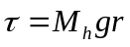.
- From 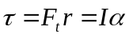 calculate I.
- Repeat for different masses and pulley radii or add a ring to the disk as assigned. Your instructor may want specific configurations. (One or two disks.)
- Compare to the calculated “static” moment of inertia:
.
- If you used the ring, find the moment of inertia of a ring, find the moment of inertia of both ring and disk together and then subtract the moment of inertia of the disk from the total moment of inertia. We would then compare this to the following equation:
where
R_{o} and R_{i} are the inner and outer radius of the ring respectively
M_{r} is the mass of the ring.
DATA
Disk:
__________
Ring:
__________
There difference between , , and r.
For disk
Hanging  Mass  M_{h}  (kg) | Hanging  Weight  M_{h}g  (N) | Radius  r  (step pulley)  (meters) | Torque  (N-m) | Lin. Acc  a  (from graph)  (m/s²) | Ang. Acc  (rad/s²) | Inertia  Experimental  (kg-m²) | Calculated  (from above)  (kg-m²) | %  difference

For ring
Hanging  Mass  M_{h}  (kg) | Hanging  Weight  M_{h}g  (N) | Radius  r  (step pulley)  (meters) | Torque  (N-m) | Lin. Acc  a  (from graph)  (m/s²) | Ang. Acc  (rad/s²) | I_{tot}  =τ /α  (kg-m²) | I_{ring=}  I_{total}-I_{disk}  Experimental  (kg-m²) | Calculated  (From above)  (kg-m²) | %  diff

